**2015**

**Nitin Kandpal, Sayan Mukhopadhyaya, Amit Kumar Haldar, Atreya Basu, Arkadeb Banerjee**

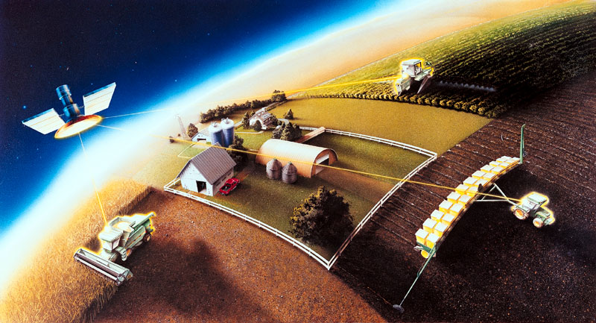

Submitted By:

Incorporation of RS & GIS in Land Management for Precision Farming

**Introduction:**

Precision agriculture, or precision farming, is therefore a farming concept that utilizes geographical information to determine field variability to ensure optimal use of inputs and maximize the output from a farm. Precision agriculture gained popularity after the realization that diverse fields of land hold different properties. Large tracts of land usually have spatial variations of soils types, moisture content, and nutrient availability and so on. Therefore, with the use of remote sensing, geographical information systems (GIS) and global positioning systems (GPS), farmers can more precisely determine what inputs to put exactly where and with what quantities. This information helps farmers to effectively use expensive resources such as fertilizers, pesticides and herbicides, and more efficiently use water resources. In the end, farmers who use this method not only maximize on their yields but also reduce their operating expenses, thus increasing their profits. On these grounds therefore, this article shall focus on the use of geospatial technologies in precision farming. To achieve this, the paper shall focus on how geospatial data is collected, analyzed and used in the decision making process to maximize on yields. The division of the land into varios zones is required which are:

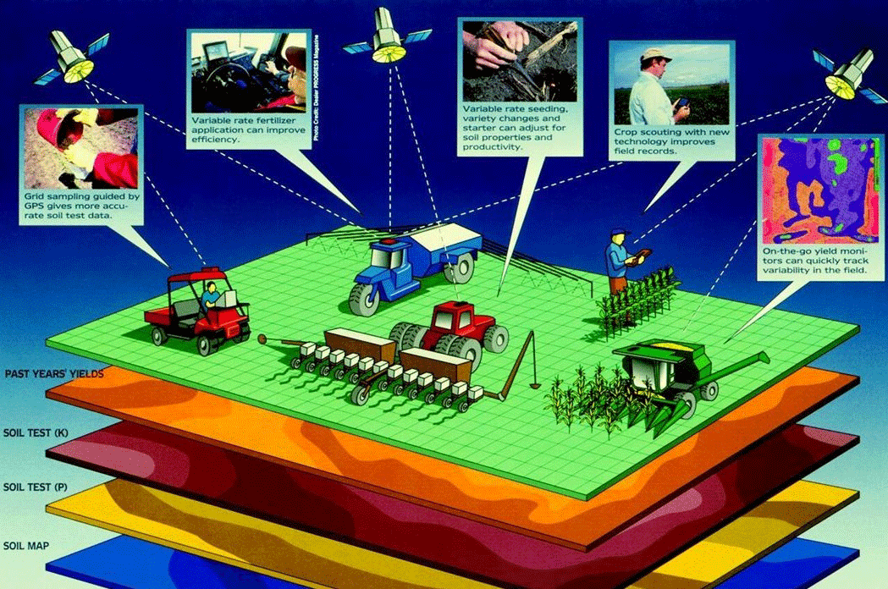

1. Soil types
2. pH rates
3. Pest infestation
4. Nutrient availability
5. Soil moisture content
6. Fertility requirements
7. Weather predictions
8. Crop characteristics
9. Hybrid responses

Land Information Management (abbreviated as LIM) for Subsidy planning is a database, designed to play a role of backend in the applications that makes planning and distribution of subsidy more clear and transparent. In our country where there are always talks about distributing subsidies or withdrawal of subsidies, this project is an effort towards managed subsidy planning.

In India farmer are given subsidy just on the basis of land (parcels) they are having for practicing agriculture, it is not seen that in that parcel what is the actual area they are cultivating, and subsidies are not given based on the need of their lands (for instance fertilizer subsidies can be given on the basis of soil profile ). These minor glitches in distribution leads to tremendous loss of government money, black marketing of seeds and fertilizers, loss in productivity and soil quality. Thus, from various studies it has been found that many times the relationship between subsidies and productivity goes negative.

**Site Information:**

The site under project is located in a small village of name Bal Nau, Jalandhar district of the state Punjab. Total site area is 306084 Sqm, which includes 53 land parcels with ownership details and soil type information.

Location Maps:

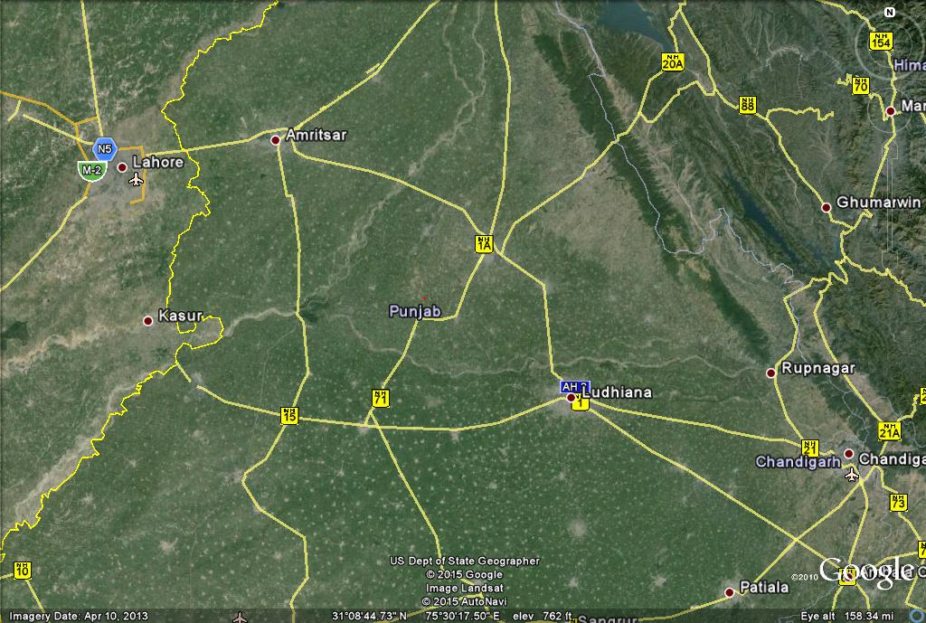

Bal Nau, Jalandhar

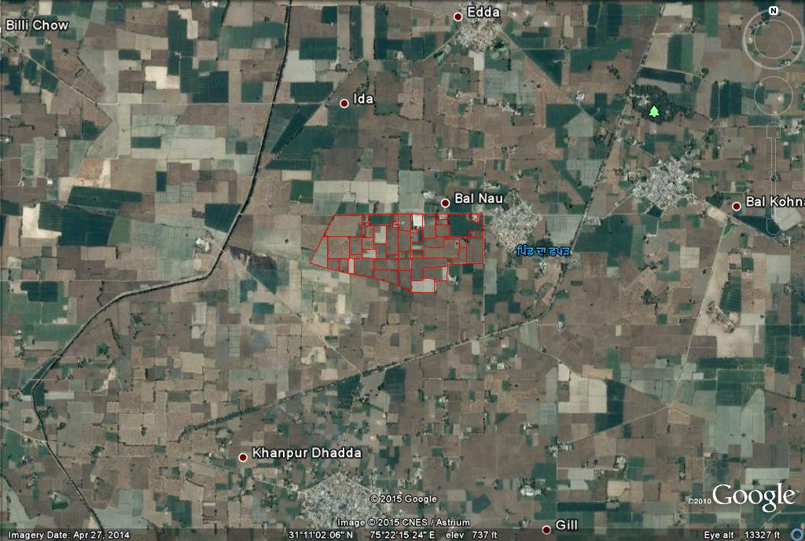

Parcel Details:

|  |  |  |  |  |  |
| --- | --- | --- | --- | --- | --- |
| Id | Landuse_Ty | Soil_Profi | Crop_Detai | Land_Owner | Area_SQM |
| 1 | Agriculture | N2-A2 | Maize | Kartar Singh | 21493 |
| 2 | Agriculture | N2-A2 | Rice | Baljinder Kaur | 10108 |
| 3 | Barren Land | N2-A3 |  | Harpreet Singh | 4129 |
| 4 | Agriculture | N2-A2 | Maize | Guljinder Jindal | 14842 |
| 5 | Agriculture | N2-A2 | Rice | Harinarayan Parekh | 3415 |
| 6 | Agriculture | N2-A3 | Rice | Shankar Singh | 2907 |
| 7 | Agriculture | N2-A3 | Maize | Gurman Singh Man | 3917 |
| 8 | Fallow Land | N2-A2 | Maize | Lathait Singh Gurjar | 7028 |
| 9 | Fallow Land | N2-A3 | Rice | Baldev Sahani | 1345 |
| 10 | Fallow Land | N2-A3 | Wheat | Nikhil Kaul | 10868 |
| 11 | Fallow Land | N2-A2 | Maize | Harendra Singh Thakur | 4093 |
| 12 | Fallow Land | N2-A2 | Maize | Man Singh | 1691 |
| 13 | Fallow Land | N2-A2 | Maize | Gopal Singh Tomar | 1954 |
| 14 | Fallow Land | N2-A2 | Maize | Praveen Singh Chauhan | 8817 |
| 15 | Fallow Land | N2-A2 | Maize | Gurmeet Kaur | 2983 |
| 16 | Fallow Land | N2-A3 | Wheat | Palvinder Singh | 8951 |
| 17 | Fallow Land | N2-A3 | Wheat | Harjeet Kaur | 6917 |
| 18 | Fallow Land | N2-A3 | Rice | Narendra Bhai | 6258 |
| 19 | Fallow Land | N2-A3 | Rice | Sahdev Kaul | 1323 |
| 20 | Built-up | N2-A3 |  | Jamuna Bai | 1017 |
| 21 | Fallow Land | N2-A3 | Wheat | Lakhan Singh | 7986 |
| 22 | Fallow Land | N2-A3 | Wheat | HArdayal Kaul | 10515 |
| 23 | Fallow Land | N2-A3 | Wheat | Krishna Agrawal | 4531 |
| 24 | Fallow Land | N2-A3 | Wheat | Niyati Chauhan | 1547 |
| 25 | Fallow Land | N2-A3 | Wheat | Khushboo Rani | 1 |
| 26 | Fallow Land | N2-A3 | Wheat | Kamlawati | 7800 |
| 27 | Fallow Land | N2-A3 | Wheat | Sateyendra Pal | 6825 |
| 28 | Fallow Land | N2-A3 | Wheat | Kartar Gurjar | 4740 |
| 29 | Fallow Land | N2-A3 | Wheat | Sakpal Singh | 9158 |
| 30 | Fallow Land | N2-A4 | Wheat | Jasdeep Kaur | 15142 |
| 31 | Fallow Land | N2-A3 | Rice | Rohan Pratap | 4 |
| 32 | Fallow Land | N2-A3 | Wheat | Jagannath Singh | 2600 |
| 33 | Fallow Land | N2-A3 | Wheat | Sarnam Singh | 1207 |
| 34 | Fallow Land | N2-A3 | Wheat | Sukhvinder PAl | 9270 |
| 35 | Fallow Land | N2-A4 | Rice | Nakul Dhagat | 13412 |
| 36 | Fallow Land | N2-A4 | Wheat | Arjun Kapoor | 4921 |
| 37 | Fallow Land | N2-A4 | Wheat | Nagarjun K. | 15813 |
| 38 | Fallow Land | N2-A3 | Wheat | Palwal Singh | 1670 |
| 39 | Fallow Land | N2-A3 | Wheat | Hridesh Gujjar | 0 |
| 40 | Agriculture | N2-A3 | Wheat | Nahal Singh | 9260 |
| 41 | Agriculture | N2-A4 | Wheat | Sarwati Bano | 3686 |
| 42 | Agriculture | N2-A3 | Rice | Nakail Singh | 19 |
| 43 | Agriculture | N2-A4 | Rice | Sanjay Kapoor | 4850 |
| 44 | Agriculture | N2-A3 | Wheat | Himani Chauhan | 9472 |
| 45 | Built-up | N2-A3 |  | Sarvesh Singh Chauhan | 6352 |
| 46 | Agriculture | N2-A3 | Wheat | Himani Sahani | 3818 |
| 47 | Agriculture | N2-A3 | Rice | Rajendra Prasad | 0 |
| 48 | Agriculture | N2-A3 | Rice | Ikabal Khan | 1892 |
| 49 | Built-up | N2-A3 |  | Rahilah Begam | 1821 |
| 50 | Agriculture | N2-A4 | Rice | Sanchar Singh | 1419 |
| 51 | Agriculture | N2-A4 | Rice | Nagendra Pal Singh | 1984 |
| 52 | Agriculture | N2-A4 | Rice | Kamal Nath | 18184 |
| 53 | Built-up | N2-A3 |  | Yogesh Kumar | 2129 |

**Scope of the Project:**

* Managing tenant farmers record so that when a land is taken for lease then in that time duration only the leaser (or tenant farmer) is eligible for subsidy and no subsidy will be given to the owner of the land.
* Monitoring the growth of the cultivation after providing subsidies and making a broad check whether the cultivation is in accordance to the subsidy provided.
* This project extension can be used by State governments, Central government, agricultural department, Research Institute and beside for subsidy planning it can be used for Crop forecasting.

**Architecture:**

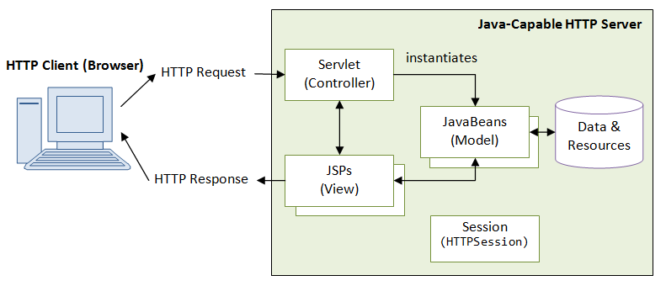

JavaScript (JS), HTML5, AJAX, JQUERY,JQUERY UI,JPLOT library and OPENLAYERS are used as front end technology. On backend, technology as JSP, Servlet and JavaBeans are used. JavaScript is used as part of [web browsers](http://en.wikipedia.org/wiki/Web_browser), whose implementations allow [client-side scripts](http://en.wikipedia.org/wiki/Client-side_scripting) to [interact with the user](http://en.wikipedia.org/wiki/User_interface), control the browser, communicate [asynchronously](http://en.wikipedia.org/wiki/Ajax_(programming)), and alter the [document content](http://en.wikipedia.org/wiki/Document_Object_Model) that is displayed.

HTML5 is a core technology [markup language](http://en.wikipedia.org/wiki/Markup_language) of the [Internet](http://en.wikipedia.org/wiki/Internet) used for structuring and presenting content for the [World Wide Web](http://en.wikipedia.org/wiki/World_Wide_Web). As of October 2014 this is the final and complete fifth revision of the [HTML](http://en.wikipedia.org/wiki/HTML) standard of the [World Wide Web Consortium](http://en.wikipedia.org/wiki/World_Wide_Web_Consortium) (W3C).HTML5 introduces [elements](http://en.wikipedia.org/wiki/HTML_element) and attributes that reflect typical usage on modern [websites](http://en.wikipedia.org/wiki/Website).

JQuery UI is a collection of [GUI widgets](http://en.wikipedia.org/wiki/GUI_widget), animated visual effects, and [themes](http://en.wikipedia.org/wiki/Theme_(computing)) implemented with [JQuery](http://en.wikipedia.org/wiki/JQuery)  (a [JavaScript](http://en.wikipedia.org/wiki/JavaScript) [library](http://en.wikipedia.org/wiki/Library_(computing))), [Cascading Style Sheets](http://en.wikipedia.org/wiki/Cascading_Style_Sheets), and [HTML](http://en.wikipedia.org/wiki/HTML). It is a [cross-platform](http://en.wikipedia.org/wiki/Cross-platform) [JavaScript library](http://en.wikipedia.org/wiki/JavaScript_library) designed to simplify the [client-side scripting](http://en.wikipedia.org/wiki/Client-side_scripting) of [HTML](http://en.wikipedia.org/wiki/HTML). JQuery is the most popular [JavaScript library](http://en.wikipedia.org/wiki/JavaScript_library) in use today. JQuery is [free, open-source software](http://en.wikipedia.org/wiki/Free_and_open_source_software) licensed under the [MIT License](http://en.wikipedia.org/wiki/MIT_License).

OpenLayers is an open source JavaScript library for displaying map data in web browsers. It provides an API for building rich web-based geographic applications similar to Google Maps and Bing Maps. The library was originally based on the Prototype JavaScript Framework.

OpenLayers supports GeoRSS, KML (Keyhole Markup Language), Geography Markup Language (GML), GeoJSON and map data from any source using OGC-standards as Web Map Service (WMS) or Web Feature Service (WFS).

A Java servlet is a [Java programming language](http://en.wikipedia.org/wiki/Java_(programming_language)) [program](http://en.wikipedia.org/wiki/Computer_program) that extends the capabilities of a [server](http://en.wikipedia.org/wiki/Server_(computing)). Although servlets can respond to any types of requests, they most commonly implement applications hosted on [Web servers](http://en.wikipedia.org/wiki/Web_server). The servlets gets the request from the client and directs it to the respective services. The servlet also transfers the response back to the client in the form of GeoJSON or XML.

PostgreSQL, often simply "Postgres", is an [object-relational database management system](http://en.wikipedia.org/wiki/Object-relational_database_management_system) (ORDBMS) with an emphasis on extensibility and standards-compliance. As a database server, its primary function is to store data securely, supporting best practices, and to allow for retrieval at the request of other software applications. It can handle workloads ranging from small single-machine applications to large [Internet-facing applications](http://en.wikipedia.org/wiki/Web_service) with many [concurrent users](http://en.wikipedia.org/wiki/Concurrent_user). Recent versions also provide replication of the database itself for availability and [scalability](http://en.wikipedia.org/wiki/Scalability).

PostGIS works along with Postgres to extend its capability to store GIS data and provide GIS functionalities.

**ER Diagram:**

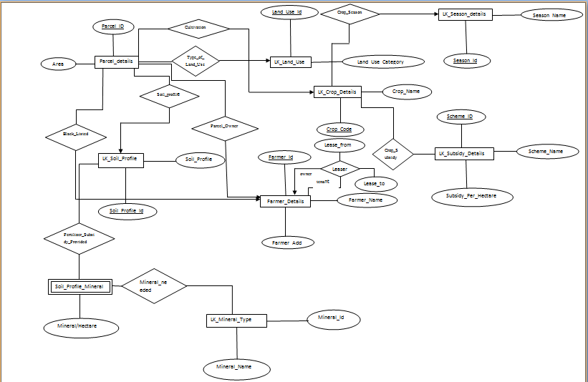

**Schema Diagram:**

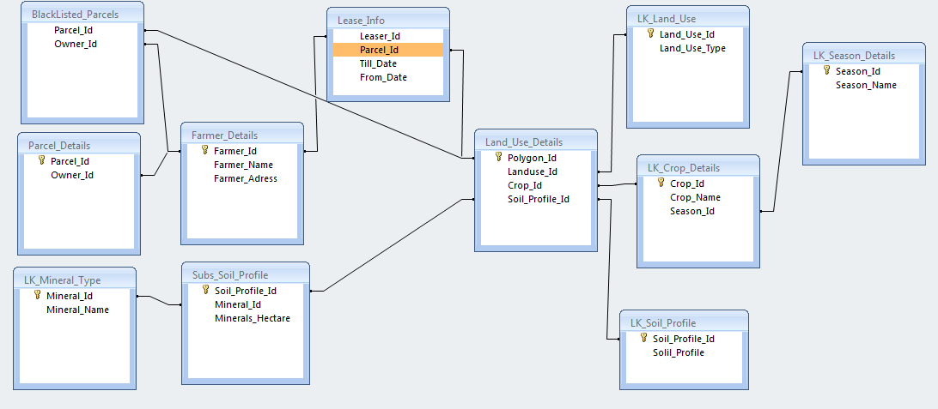

**Project Implementation:**

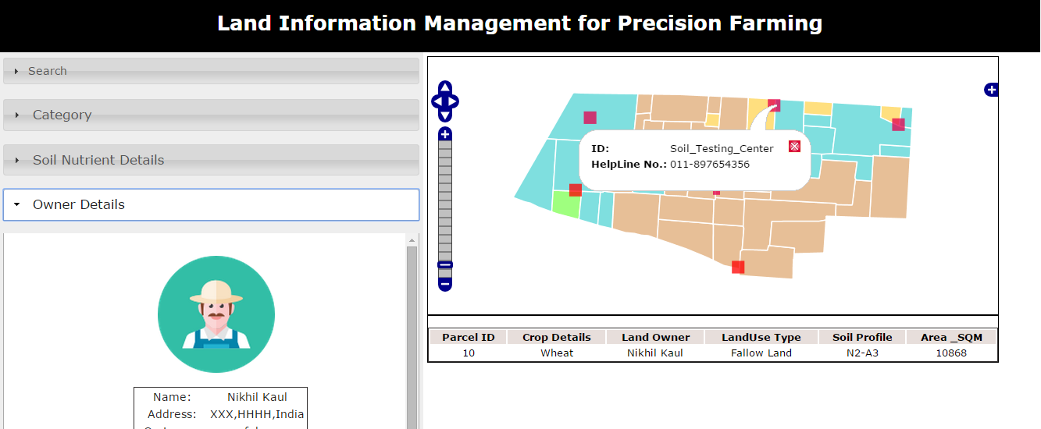

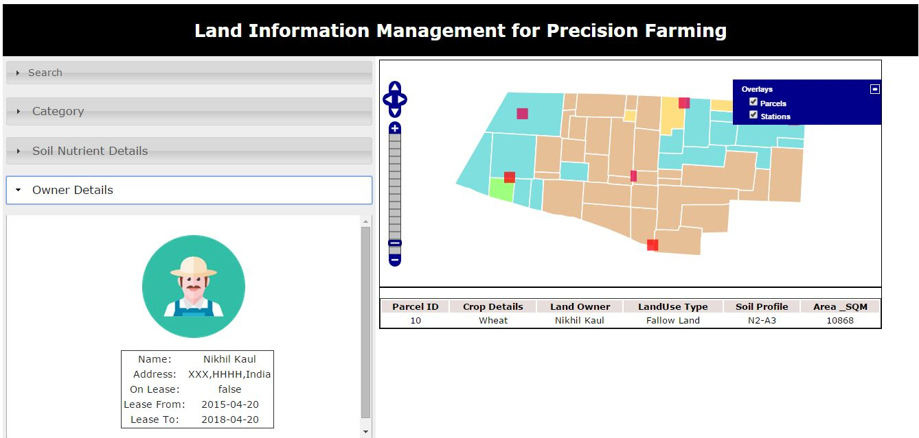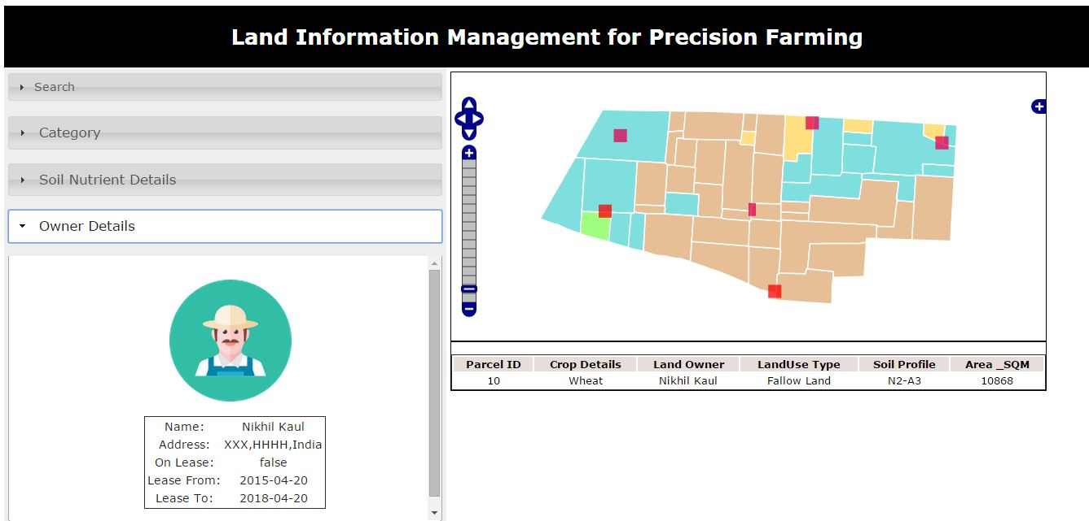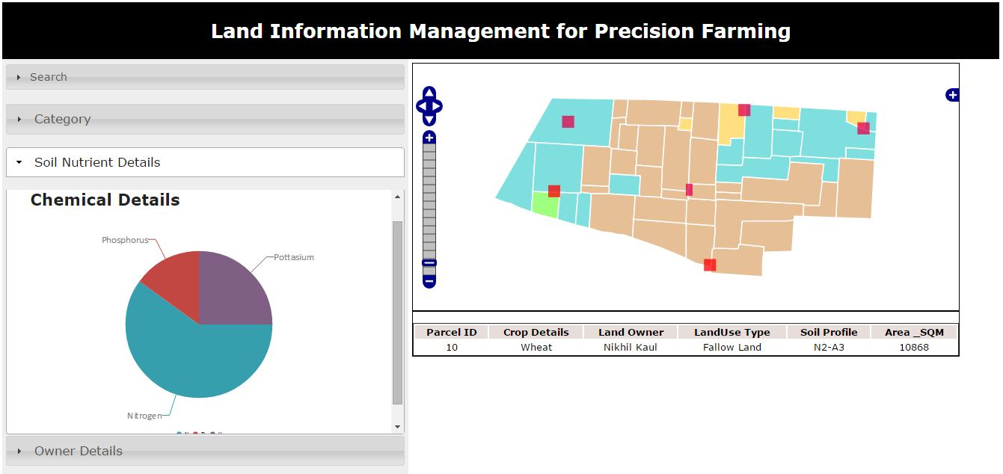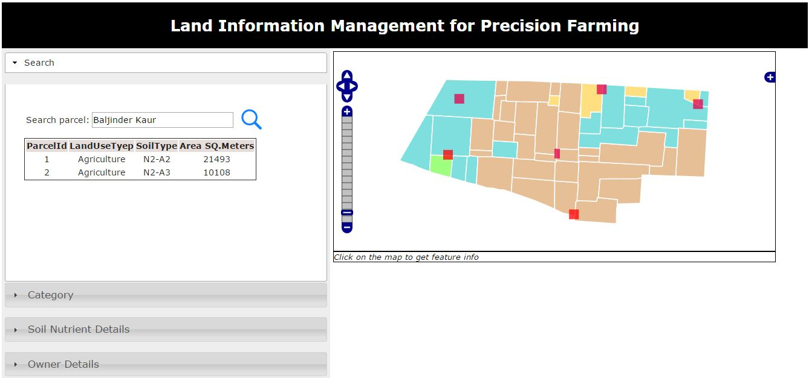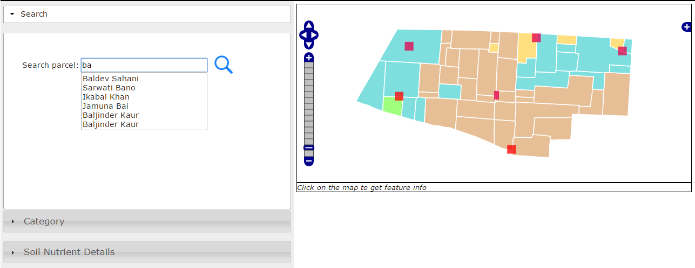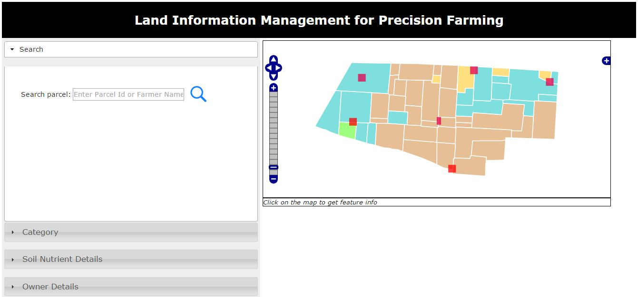

**Conclusions:**

Idea behind this project was to develop such a system wherein the farmers along with the officials can get the information about any agriculture parcels. Information will include the ownership details soil types information, chemical content, crop rotation details etc. So far we could publish the parcel layer including all the information.

**References:**

[*http://en.wikipedia.org/wiki/Precision_agriculture*](http://en.wikipedia.org/wiki/Precision_agriculture)

[*http://www1.agric.gov.ab.ca/$department/deptdocs.nsf/all/sag1951*](http://www1.agric.gov.ab.ca/$department/deptdocs.nsf/all/sag1951)

[*http://www.agcocorp.com/precision-farming.html*](http://www.agcocorp.com/precision-farming.html)